ASBESTOS SURVEY REPORT

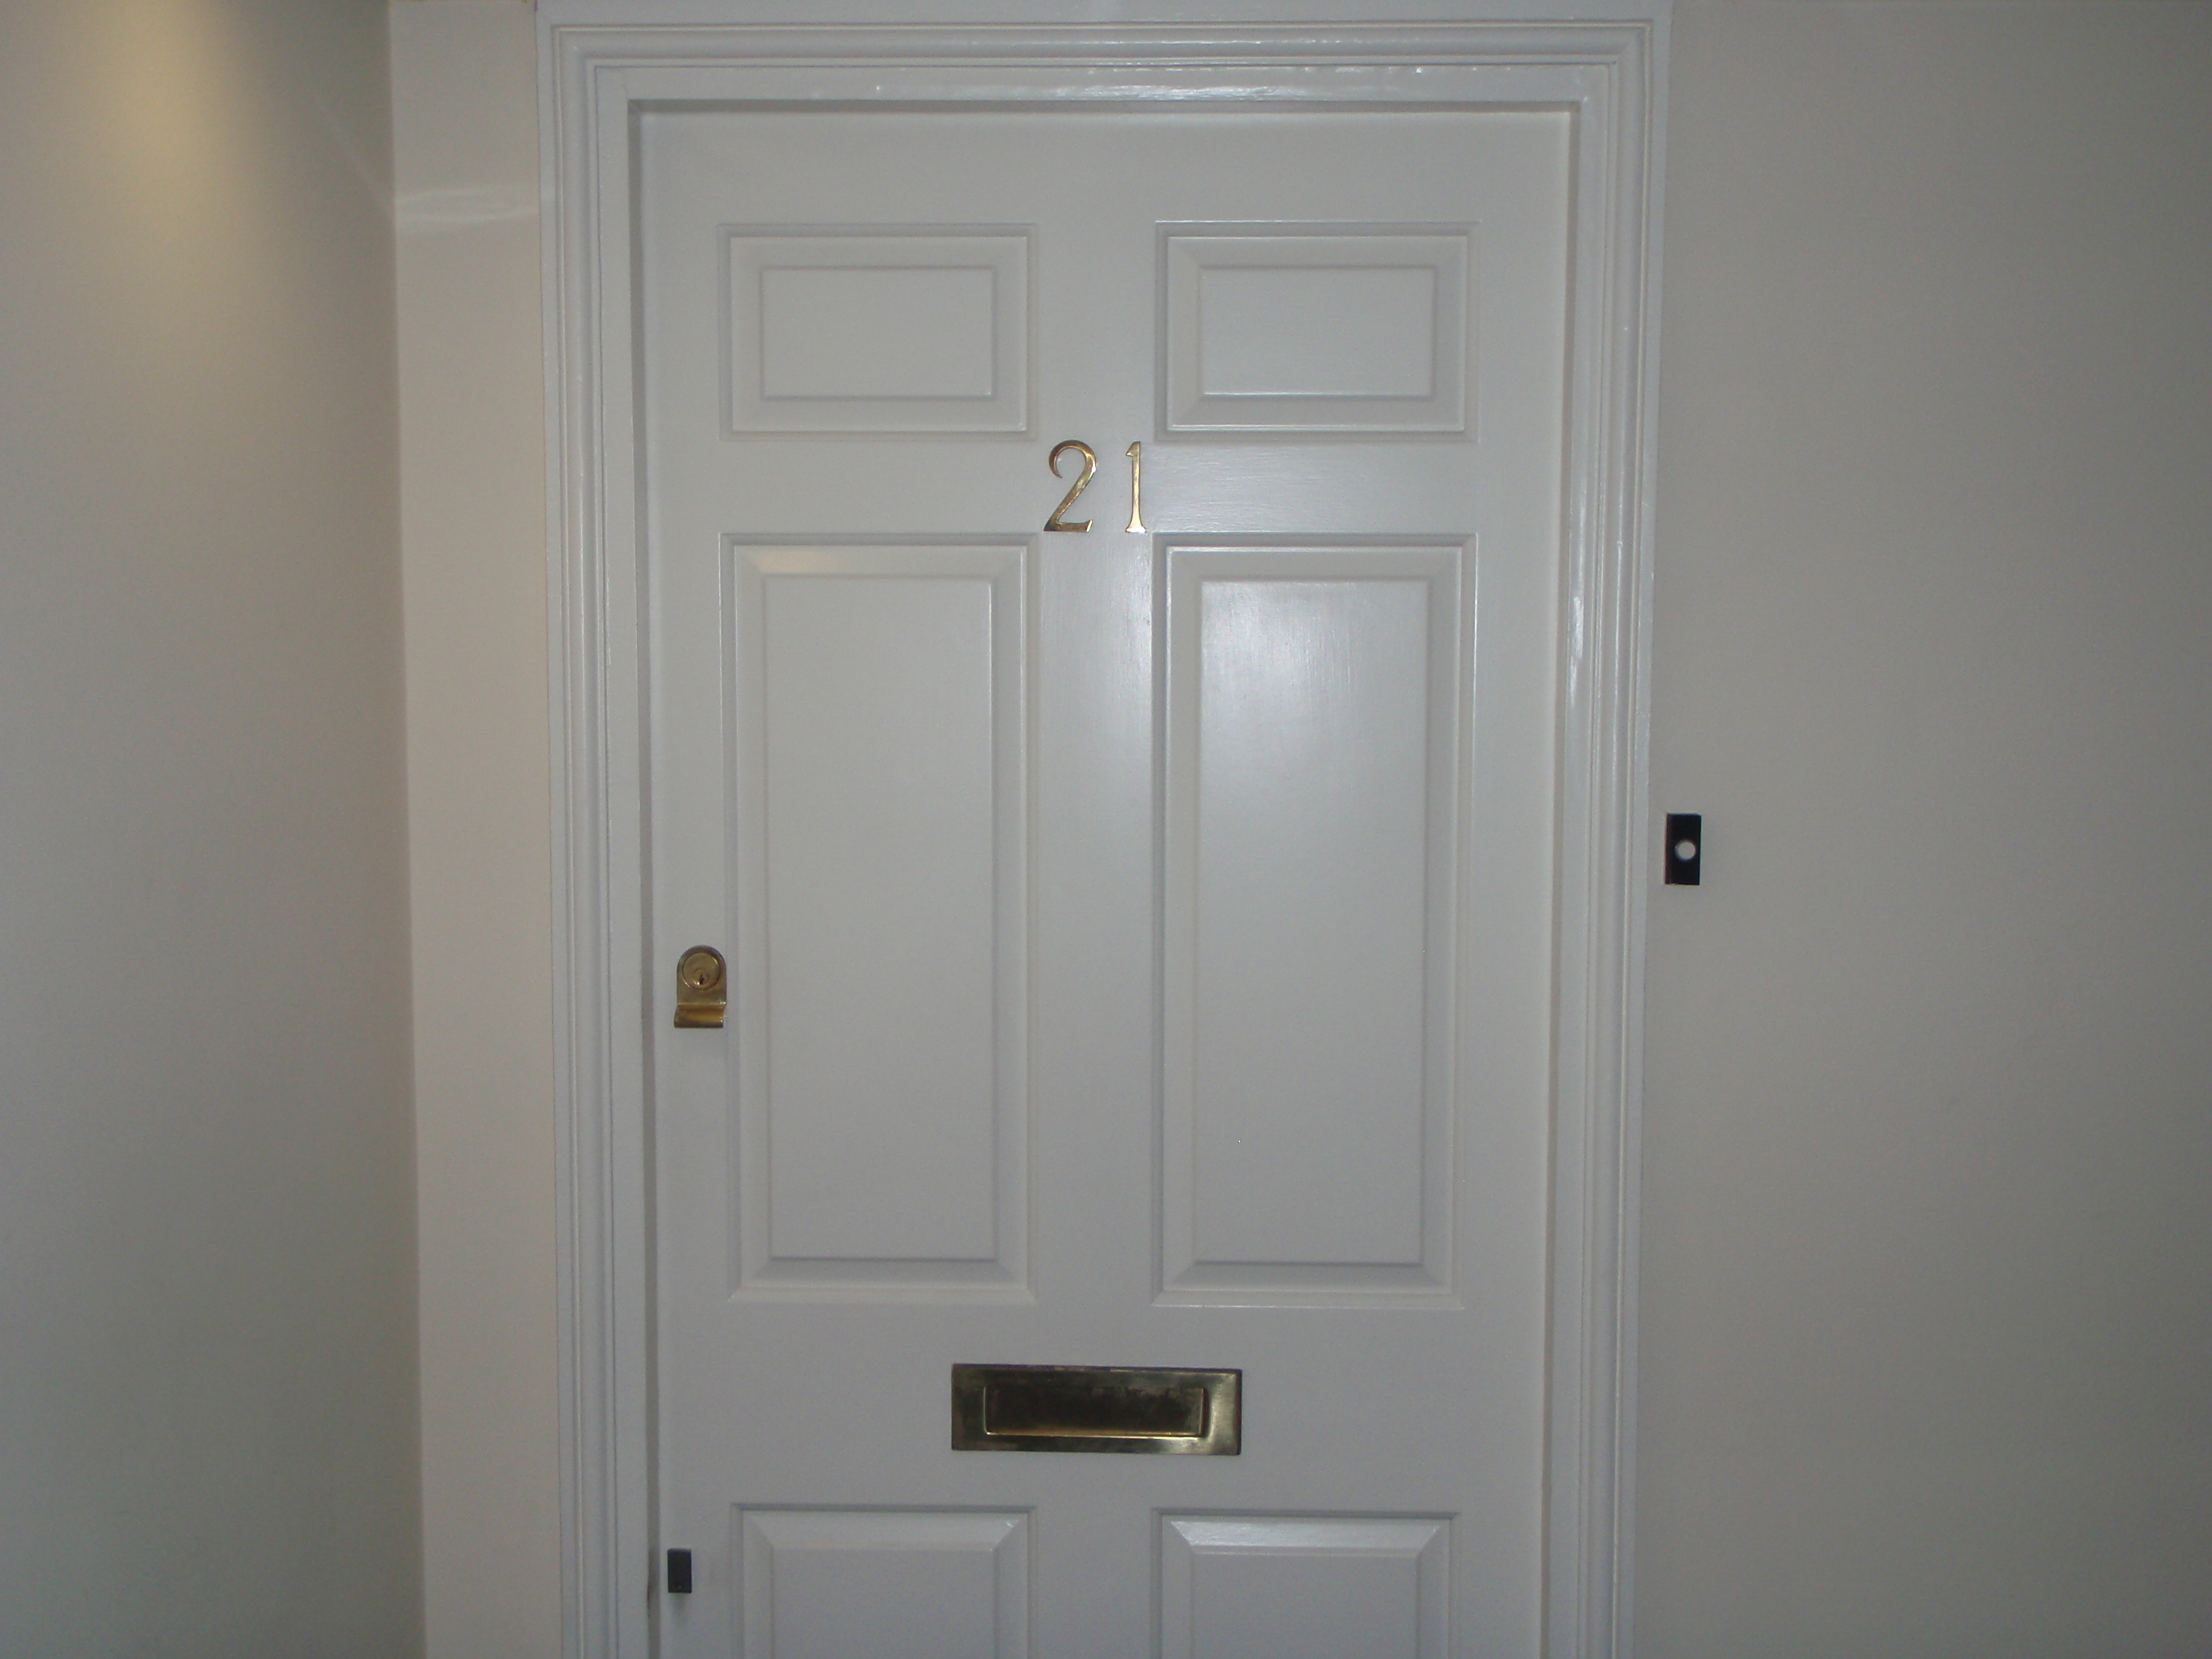

Flat 21 George Laybourne House
Wellclose Square
London
E1 8HW

On behalf of

Entry Limited
George Laybourne House
Wellclose Square
London
E1 8HW

REPORT PRODUCTION

Report Prepared By: John Hill

Position in Company Surveyor

Signature: ------------------------ Date: 09/11/2009.

Report Reviewed By: Karen Anderson

Position in Company Administrator

Signature ------------------------ Date: 09/11/2009.

POINTS OF CONTACT

AMIANTE LIMITED
Unit 4
Walthamstow Business Centre
Clifford Road
Walthamstow
London
E17 4SX
Tel: 020 8531 4969
Fax: 020 8531 9281

Entry Limited
George Laybourne House
Wellclose Square
London
E1 8HW

CONTENTS PAGE

SECTION 1

- Report Details

- Introduction

- Survey Methodology

- General Recommendations For Asbestos Cement Products

- General Recommendation For Asbestos Insulation, Coatings

Or Insulating Board (AIB)

- Survey Summary & Recommendations

- Risk Assessment Formulae

SECTION 2

- Identification & Photographic Register Sheets

- Survey Recommendations

- Laboratory Certificate Of Analysis

INTRODUCTION

Further to a request from Mr Tony Horton of 21 George Laybourne House Amiante Limited were instructed to carry out a survey of the site known as:

Flat 21
George Laybourne House
Fletcher Street
London
E1 8HW

There are 3 designated categories of Asbestos surveys currently available. These are listed below:

Type 1: Location and Assessment survey (Presumptive Survey) the purpose of which is to locate as far as reasonably practicable the presence and extent of any suspect asbestos containing materials in the building and assess their condition. This survey essentially defers the need to sample and analyse for asbestos until a later time.

Type 2: Standard sampling, identification and assessment survey (Sampling Survey), the purpose of which is to locate as far as reasonably practicable the presence and extent of any suspect asbestos containing materials in the building and their condition. This is done by the collection and analysis of samples of suspect asbestos containing materials.

Type 3: Full access sampling and identification survey (Pre-demolition Major Refurbishment Survey). This type of survey is used to locate and describe as far as reasonably practicable, all asbestos containing materials in the building and may involve destructive inspection as necessary to gain access to all areas, including those that may be difficult to reach. A full sampling programme is undertaken to identify possible asbestos containing materials and estimates of the volume and surface areas of asbestos containing materials made.

Access arrangements were made with Mr Horton to ensure all accessible areas were surveyed during the project.

The survey was carried out on 06/10/2009 and completed in 1 .

The survey was to include for visual inspection within the above premises.

The survey was undertaken and completed by a member of the Amiante Limited survey team.

During the survey the building remained .

DISCLAIMER

Every effort has been made to identify all asbestos materials so far as was reasonably practical to do so within the scope of the survey and the attached report. Methods used to carry out the survey were agreed with the client prior to any works being commenced.

Survey techniques used involves trained and experienced surveyors using the combined approach with regard to visual examination and necessary bulk sampling. It is always possible after a survey that asbestos based materials of one sort or another may remain in the property or area covered by that survey, this could be due to various reasons:

- Asbestos materials existing within areas not specifically covered by this report are therefore outside the scope of the survey.

- Materials may be hidden or obscured by other items or cover finishes i.e. paint, over boarding, disguising etc. Where this is the case then its detection will be impaired.

- Asbestos may well be hidden as part of the structure to a building and not visible until the structure is dismantled at a later date.

- Debris from previous asbestos removal projects may well be present in some areas; general asbestos debris does not form part of this survey however all good intentions are made for its discovery.

- Where an area has been previously stripped of asbestos i.e. plant rooms, ducts etc. and new coverings added, it must be pointed out that asbestos removal techniques have improved steadily over the years since its introduction. Most notably would be the Control of Asbestos at Work Regulations (1987) laying down certain enforceable guidelines. Asbestos removal prior to this regulation would not be of today’s standard and therefore debris may be present below new coverings.

- This survey will detail all areas accessed and all samples taken, where an area is not covered by this survey it will be due to No Access for one reason or another i.e. working operatives, sensitive location or just simply no access. It may have been necessary for the limits of the surveyor’s authority to be confirmed prior to the survey.

- Access for the survey may be restricted for many reasons beyond our control such as height, inconvenience to others, immovable obstacles or confined space. Where electrical equipment is present and presumed in the way of the survey no access will be attempted until proof of its safe state is given. Our operatives have a duty of care under the Health and Safety at Work act (1974) for both themselves and others.

DISCLAIMER

- In the building where asbestos has been located and it is clear that not all areas have been investigated, any material that is found to be suspicious and not detailed as part of the survey should be treated with caution and sampled accordingly.

- Certain materials contain asbestos to varying degrees and some may be less densely contaminated at certain locations (Artex for example). Where this is the case the sample taken may not be representative of the whole product throughout.

- Where a survey is carried out under the guidance of the owner of the property or his representative, then the survey will be as per his instructions and guidance at that time.

- Amiante Limited cannot accept any liability for loss, injury, damage or penalty issues due to errors or omissions within this report.

- Amiante Limited cannot be held responsible for any damage caused as part of this survey carried out on your behalf. Due to the nature and necessity of sampling for asbestos some danger is unavoidable and will be limited to just that necessary for the taking of the sample.

GENERAL RECOMMENDATIONS FOR
ASBESTOS CEMENT PRODUCTS

- Work with cement products containing asbestos is not included in the provisions of the Asbestos (Licensing) Regulations 1983, but is covered by the Health & Safety at Work Act 1974 and Control of Asbestos Regulations (CAR) 2006.

- An assessment of all proposed works which may disturb any asbestos should be carried out to establish the risk presented, the appropriate precautions must be adopted to control any exposure. This should incorporate the following general principles:

- Where work on asbestos cement is unavoidable, keep the materials wet during work and avoid breakage wherever possible. Adequate PPE must be worn at all times.

- Avoid using power tools. If deemed necessary to use power tools set at the lowest possible speed, localised exhaust ventilation such as cowls must be fitted to power tool and utilising the “shadowing technique” with high efficiency H type vacuum units.

- Organise the work in a single controlled location where practical, to simplify control and supervision. Segregate working areas using warning signs and tape barriers, or in case of significant fibre levels by means of a sealed polythene work enclosure and negative pressure equipment. Air tests must also be carried out by an independent analytical laboratory.

- Denote respirator zones where the Control Limit is likely to be exceeded and ensure that all persons entering the zones wear appropriate RPE/PPE and are trained in its use.

- Ensure that those persons employed in working on asbestos cement are suitably trained in the correct working practices, control methods and prevention of risks.

- Keep the work area clean during the work and use methods that minimise dust creation, avoid sweeping and brushing, which will make dust airborne.

- Dispose of asbestos cement waste safely as Special Waste under the statutory consignment note procedures in accordance with the Control of Asbestos Waste Regulations 2002.

- Avoid further disturbance of asbestos cement products wherever possible by relocating or re-routing services.

- Clearly identify and label any asbestos cement products.

GENERAL RECOMMENDATIONS FOR ASBESTOS
INSULATION, COATINGS OR INSULATING BOARD (AIB)

Where the materials are in safe condition and the risk of disturbance is negligible, they can be maintained on site. They should be identified with adequate warning signs and routinely inspected for damages. All asbestos materials should not be drilled, abraded or disturbed in any way.

All asbestos containing materials should be removed prior to any planned refurbishment or demolition works, where damage is likely to be sustained during the occupant’s activities or where future deterioration is likely.

Work on any of these items may only be carried out by a specialist contractor licensed by the Health & Safety Executive. The selected contractor is required to notify the HSE at least 14 days prior to commencement of the works, and to provide a written Method Statement as follows:

- Full description of the works to be carried out and its duration.

- Type, quantity and location of asbestos to be removed.

- Anticipated exposure levels and persons affected.

- Enclosure construction details, layout and location, signage and ventilation including volume calculations and siting.

- Precautions to be adopted to minimise exposure to lowest possible level and to control release of asbestos fibre beyond work area.

- Justification for any departure from preferred methods, e.g. where wet stripping cannot be used.

- Type, use and decontamination of RPE/PPE

- Waste removal and disposal procedures

- Training and instruction of employees

- Emergency procedures on site

Prior to the commencement of any work, the contractor should be able to supply the employer with a copy of the notification form (ASB5) for the project, together with the method statement/plan of work , current license for work with asbestos insulation or asbestos coating or asbestos insulation board, and current insurance details.

SURVEY SUMMARY

The following asbestos products were identified during the survey either by collection and analysis of representative samples, or by visual recognition at the discretion of the surveyor.

ASBESTOS THERMAL INSULATION PRODUCTS

Sample Ref | Description | Location
No Asbestos Detected

ASBESTOS INSULATION BOARD PRODUCTS

Sample Ref | Description | Location
No Asbestos Detected

ASBESTOS CEMENT PRODUCTS

Sample Ref | Description | Location
No Asbestos Detected

SURVEY SUMMARY

ASBESTOS FABRIC FLASH GUARDS

Sample Ref | Description | Location
No Asbestos Detected

TEXTURED COATINGS PRODUCTS

Sample Ref | Description | Location
L/AMI1/174/001 | Textured Coating | Living Room
L/AMI1/174/002 | Textured Coating | Kitchen
L/AMI1/174/003 | Textured Coating | Bedroom 2 En-Suite Bathroom
L/AMI1/174/004 | Textured Coating | Bedroom 2
L/AMI1/174/005 | Textured Coating | Bedroom 1
L/AMI1/174/006 | Textured Coating | Bathroom
L/AMI1/174/007 | Textured Coating | Hallway

NON ASBESTOS ITEMS

Sample Ref | Description | Location
N/A

SURVEY SUMMARY

VINYL FLOOR TILES

Sample Ref | Description | Location
No Asbestos Detected

BITUMEN PRODUCTS

Sample Ref | Description | Location
No Asbestos Detected

GASKETS

Sample Ref | Description | Location
No Asbestos Detected

RISK ASSESSMENT FORMULAE

Guidance Note MDHS 100 prescribes the formula by which the relative risk of each asbestos incidence can be assessed. A total risk score of between 0 and 12 is calculated using four categories that are evaluated by the surveyor against given values. The criteria and the respective values are as follows:

PRODUCT TYPE

1 pt | Asbestos reinforced composites such as plastics, resins, mastic, felt, vinyl tiles, paints and decorative finishes, asbestos cement products
2 | Asbestos insulating board, mill boards, other low density insulation boards, asbestos textiles, gaskets, ropes, paper etc
3 | Thermal insulation, sprayed asbestos, loose asbestos, mattresses and packing

EXTENT OF DAMAGE

0 pt | Good condition, no visible damage
1 | Low damage, a few scratches or surface marks, broken edges of boards, tiles etc
2 | Medium damage, significant breakage of materials or several small areas where fibres are exposed
3 | High damage or delamination of materials, sprays and thermal insulation, visible asbestos debris

SURFACE TREATMENT

0 pt | Composite products such as plastics, resins and tiles
1 | Enclosed sprays and lagging, boards with exposed surface painted or sealed, asbestos cement products
2 | Unsealed boards or sealed lagging sprays
3 | Unsealed boards or sealed lagging and sprays

RISK ASSESSMENT FORMULAE
ASBESTOS TYPE

1 pt | Chrysotile (white) asbestos
2 | Amosite (brown) asbestos
3 | Crocidolite (blue) asbestos

The algorithms shown against each situation are added together to give a total risk score, for the purpose of brevity, the register we have prepared contains only the total risk score rather than the component scores.

The total score for each situation can be broadly classified using the following bands:

Up to 4 Points | Very Low Risk
5 - 6 Points | Low Risk
7 – 9 Points | Medium Risk
10 – 12 | Points High Risk

It is likely that high risk items will be highlighted in the report text and that some immediate action will be required. Other items may also be considered for attention where the discretion of the surveyor suggests this would be expedient.

IDENTIFICATION & PHOTOGRAPHIC REGISTER SHEETS

AMIANTE LTD

IDENTIFICATION & PHOTOGRAPHIC REGISTER SHEET

SITE: Flat 21, George Laybourne House,
Fletcher Street, London, E1 8HW

ENQUIRY NO: LS5916

SURVEY DATE: 06/10/2009

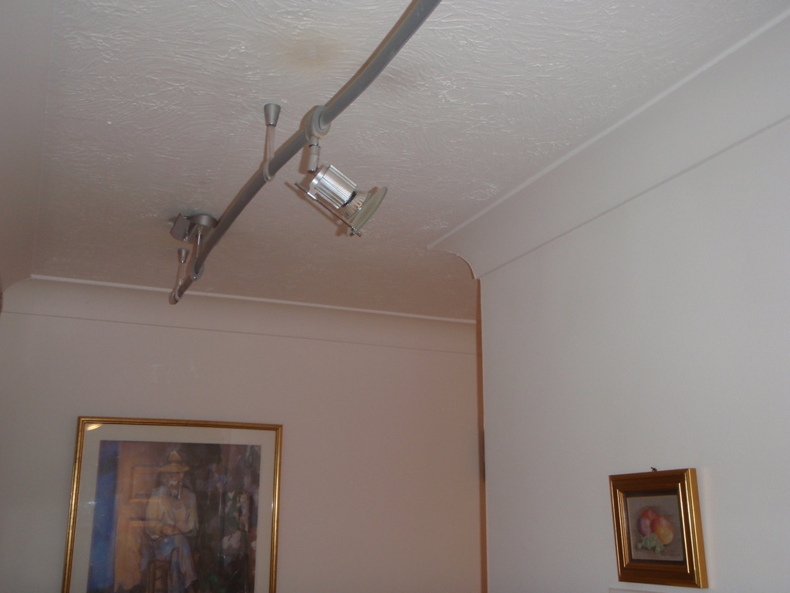

Photograph No. | P1010001
Location | Hallway - Textured Coating
Sample No. | L/AMI1/174/007
Analysis
Quantity | 10M²
Risk Score
Comments

AMIANTE LTD

IDENTIFICATION & PHOTOGRAPHIC REGISTER SHEET

SITE: Flat 21, George Laybourne House,
Fletcher Street, London, E1 8HW

ENQUIRY NO: LS5916

SURVEY DATE: 06/10/2009

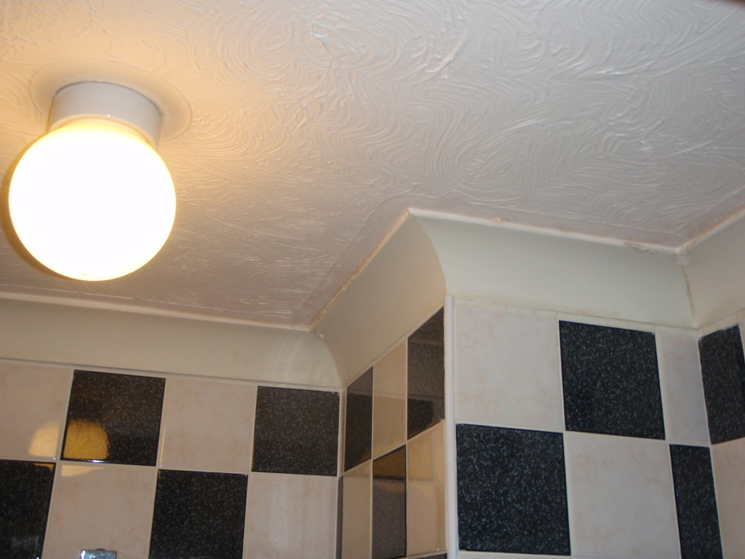

Photograph No. | P1010002
Location | Bathroom - Textured Coating
Sample No. | L/AMI1/174/006
Analysis
Quantity | N/A
Risk Score
Comments

AMIANTE LTD

IDENTIFICATION & PHOTOGRAPHIC REGISTER SHEET

SITE: Flat 21, George Laybourne House,
Fletcher Street, London, E1 8HW

ENQUIRY NO: LS5916

SURVEY DATE: 06/10/2009

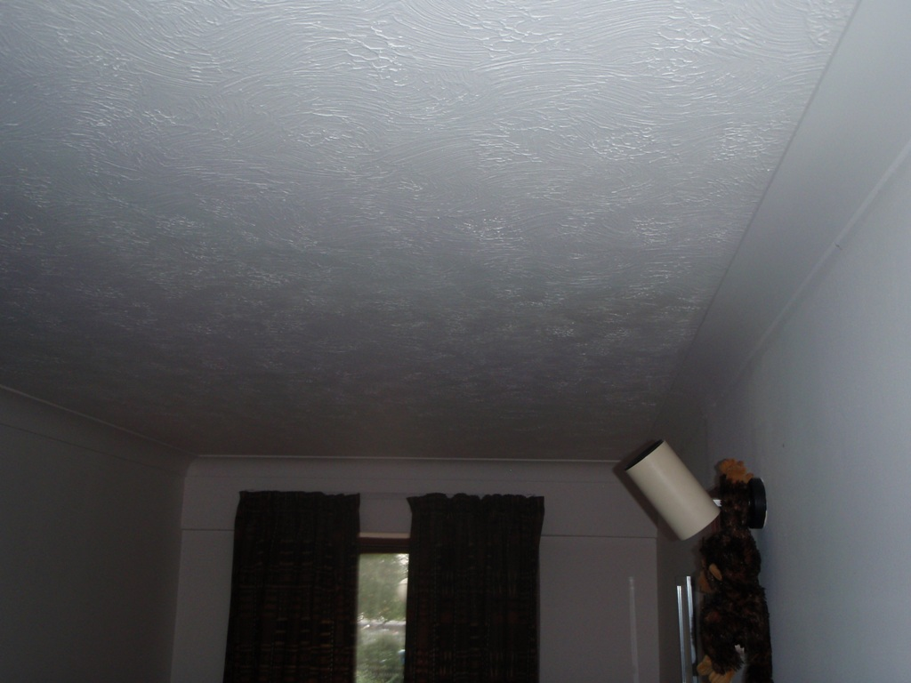

Photograph No. | P1010003
Location | Bedroom 1 - Textured Coating
Sample No. | L/AMI1/174/005
Analysis
Quantity | 6M²
Risk Score
Comments

AMIANTE LTD

IDENTIFICATION & PHOTOGRAPHIC REGISTER SHEET

SITE: Flat 21, George Laybourne House,
Fletcher Street, London, E1 8HW

ENQUIRY NO: LS5916

SURVEY DATE: 06/10/2009

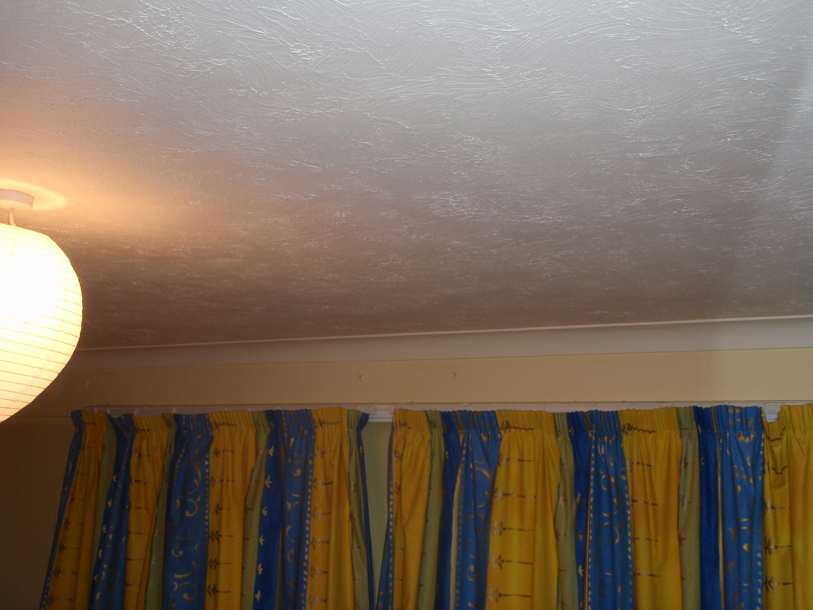

Photograph No. | P1010004
Location | Bedroom 2 - Textured Coating
Sample No. | L/AMI1/174/004
Analysis
Quantity | 15M²
Risk Score
Comments

AMIANTE LTD

IDENTIFICATION & PHOTOGRAPHIC REGISTER SHEET

SITE: Flat 21, George Laybourne House,
Fletcher Street, London, E1 8HW

ENQUIRY NO: LS5916

SURVEY DATE: 06/10/2009

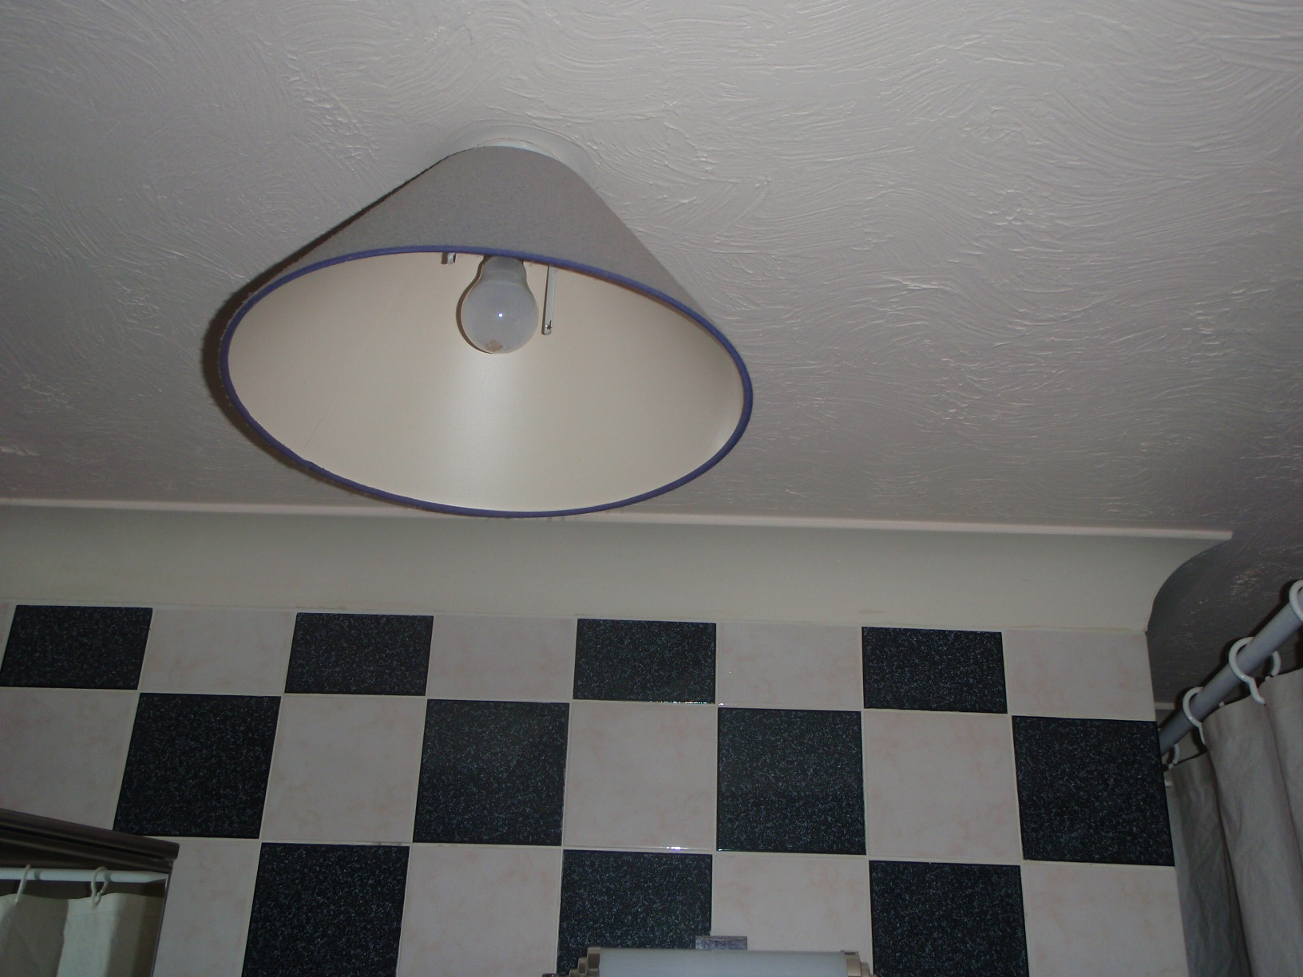

Photograph No. | P1010005
Location | Bedroom 2 Ensuite Bathroom - Textured Coating
Sample No. | L/AMI1/174/003
Analysis
Quantity | 2M²
Risk Score
Comments

AMIANTE LTD

IDENTIFICATION & PHOTOGRAPHIC REGISTER SHEET

SITE: Flat 21, George Laybourne House,
Fletcher Street, London, E1 8HW

ENQUIRY NO: LS5916

SURVEY DATE: 06/10/2009
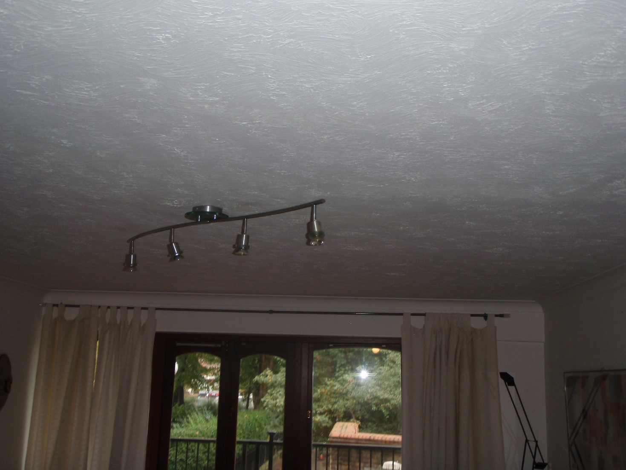

Photograph No. | P1010006
Location | Living Room - Textured Coating
Sample No. | L/AMI1/174/001
Analysis
Quantity | 21M²
Risk Score
Comments

AMIANTE LTD

IDENTIFICATION & PHOTOGRAPHIC REGISTER SHEET

SITE: Flat 21, George Laybourne House,
Fletcher Street, London, E1 8HW

ENQUIRY NO: LS5916

SURVEY DATE: 06/10/2009

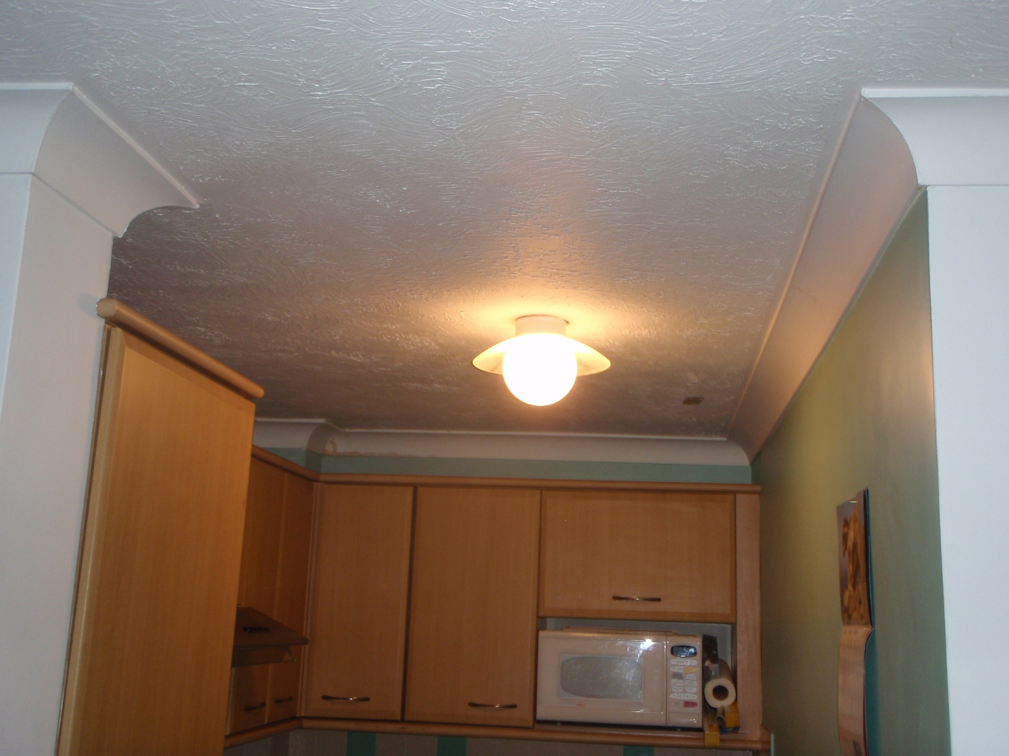

Photograph No. | P1010007
Location | Kitchen - Textured Coating
Sample No. | L/AMI1/174/002
Analysis
Quantity | 3M²
Risk Score
Comments

AMIANTE LTD

IDENTIFICATION & PHOTOGRAPHIC REGISTER SHEET

SITE: Flat 21, George Laybourne House,
Fletcher Street, London, E1 8HW

ENQUIRY NO: LS5916

SURVEY DATE: 06/10/2009

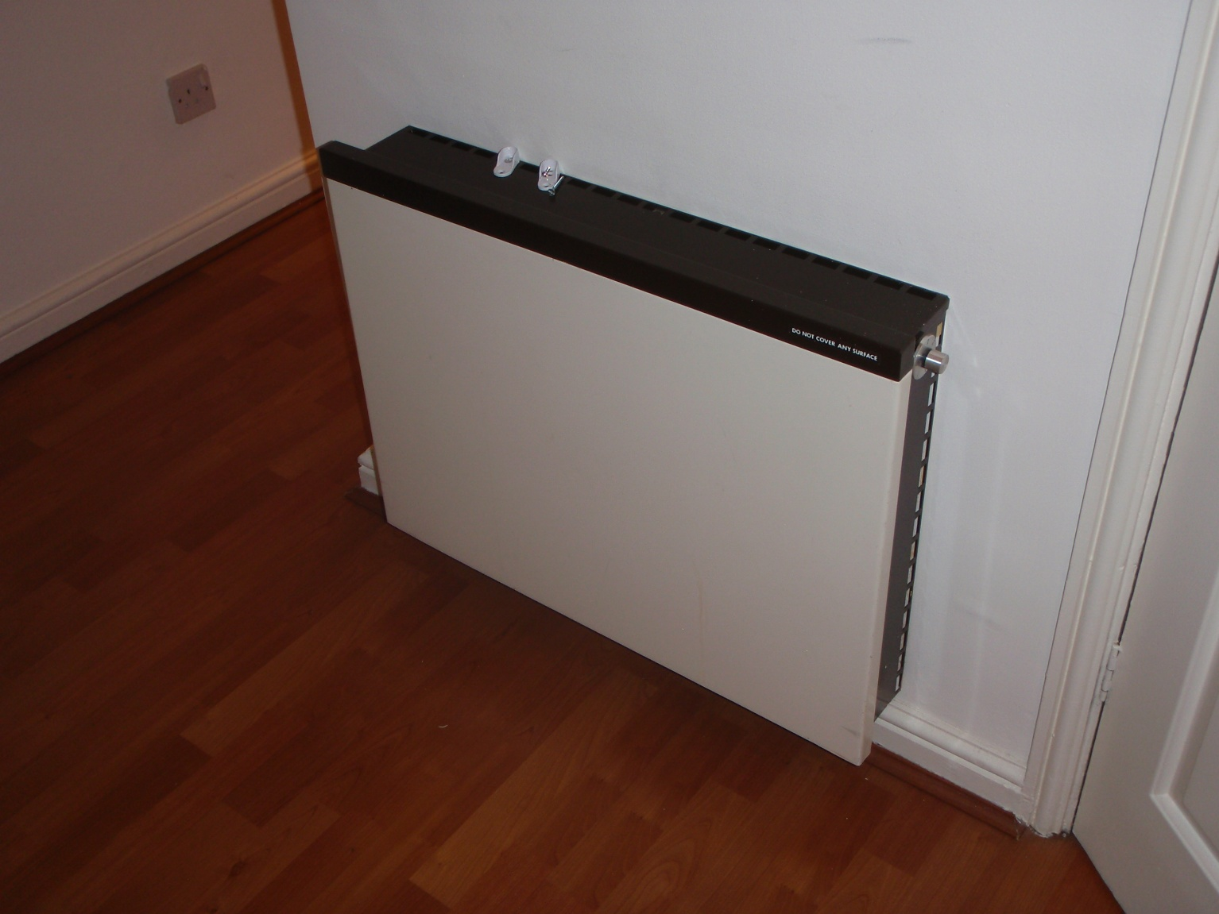

Photograph No. | P1010008
Location | Storage Heaters
Sample No. | No Access
Analysis
Quantity | 4 No.
Risk Score
Comments

SURVEY RECOMMENDATIONS

The following asbestos based products were identified during the survey either by collection and analysis of representative samples, or by visual inspection and recognition by the surveyor.

As all textured coated containing asbestos are already encapsulated (painted) we recommend that they are labelled and managed.

All storage heaters should be labelled and managed as they may contain asbestos materials.

